2. ER-Diagram (Entity-Relationship)
The ER-Diagram illustrates the relationships between core entities: Users, Properties, and Bookings.
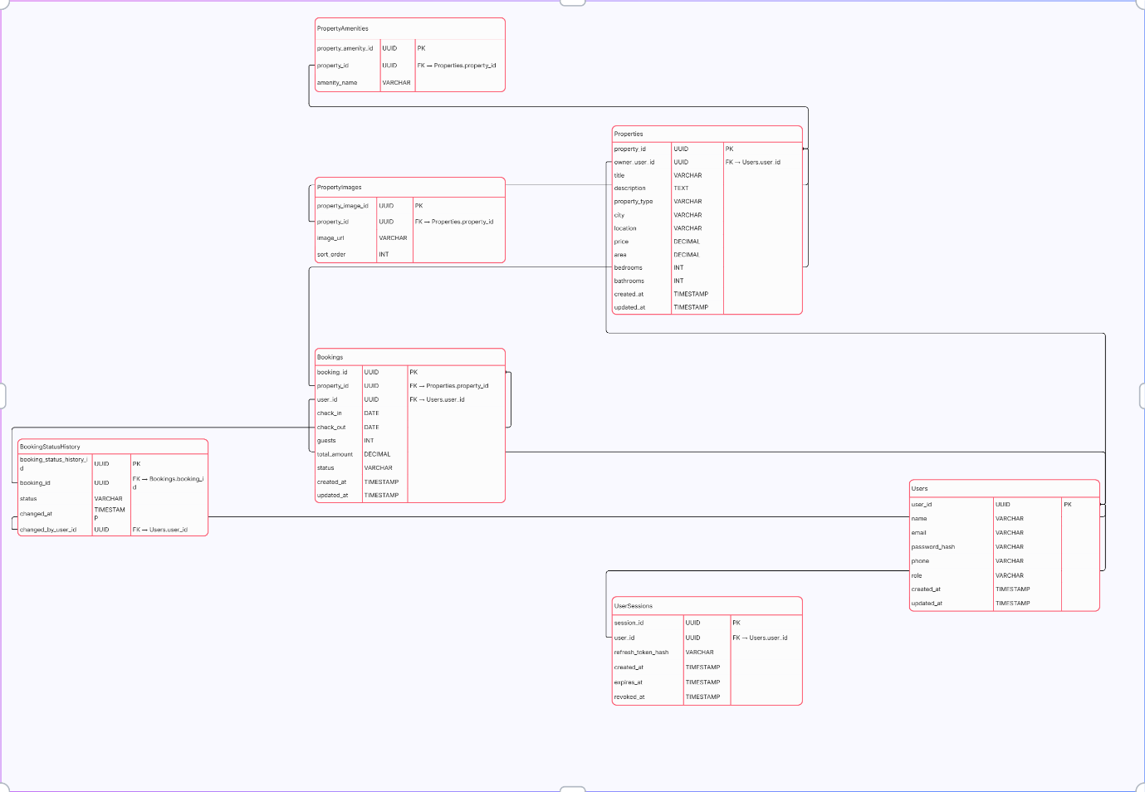
Entity Descriptions & Relationships:
- USERS: The core entity storing credentials, contact info, and role-based access data.
- PROPERTIES: Detailed listings linked to an Owner, containing spatial and pricing attributes.
- BOOKINGS: Junction entity managing the rental agreement between a User and a Property.
- USER_SESSIONS: Ensures secure session persistence and token refresh mechanisms.
- PROPERTY_AMENITIES & IMAGES: One-to-many extensions for handling multi-valued attributes and visual assets.
- BOOKING_STATUS_HISTORY: An audit trail tracking state transitions (e.g., from 'Pending' to 'Confirmed') for transparency.

